UCA Setups

**1. Posting the Sales Order**

**Impact on Accounts:**

* **Revenue Account (Rent Income):** The G/L account you used for recording rent income will be credited with the amount of the invoice. This increases your rent income in the financial statements.
* **Accounts Receivable:** The customer’s account in the Accounts Receivable ledger will be debited, representing the amount the customer owes. This increases your receivables.

**Example:**

* **G/L Account for Rent Income** (e.g., Rent Income) will be credited.
* **Accounts Receivable** (e.g., Debtors Account) will be debited.

**2. Receiving Payment**

When the customer makes a payment, you need to record this payment to clear the invoice:

**Steps to Record Payment:**

1. **Navigate to Customer Payments:**
   * Go to **Sales** > **Cash Receipt Journals** or **Bank Receipt Journals** depending on how you are processing the payment.
2. **Record the Payment:**
   * Create a new journal entry or record a new payment.
   * Enter the customer’s details and the amount received.
   * Apply the payment to the outstanding invoice.
3. **Post the Payment:**
   * Post the payment entry.

**Impact on Accounts:**

* **Accounts Receivable:** The customer’s account in the Accounts Receivable ledger will be credited, reducing the amount the customer owes. This decreases your receivables.
* **Bank Account (or Cash Account):** The bank or cash account used to receive the payment will be debited, reflecting the increase in cash or bank balance.
* **Even account Receivable for rent will be credited to reduce the amount of money we demand the customers**

**Example:**

* **Accounts Receivable** (e.g., Debtors Account) will be credited to reflect the payment received.
* **Bank Account** (e.g., Checking Account) will be debited to reflect the increase in cash.

**Summary of Impact**

* **Posting the Invoice:**
  + Increases rent income in your G/L account.
  + Increases Accounts Receivable (what you are owed).
* **Receiving Payment:**
  + Decreases Accounts Receivable (what you are owed).
  + Increases the cash or bank account balance.

These transactions ensure that your financial records remain accurate and reflect the true state of your business’s finances.

Vendor Posting Groups

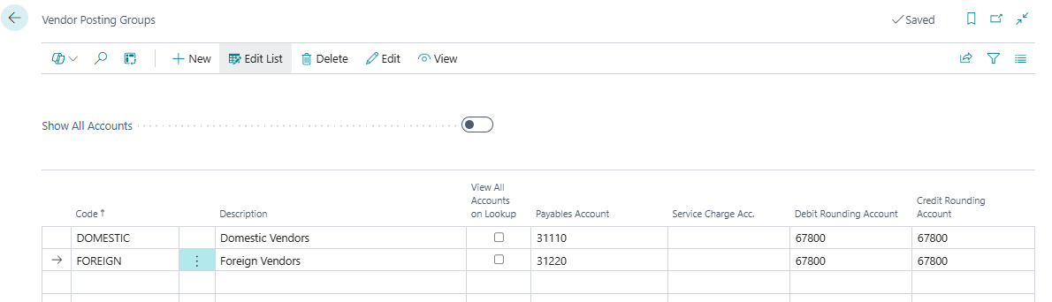

Gen Bus Posting Groups

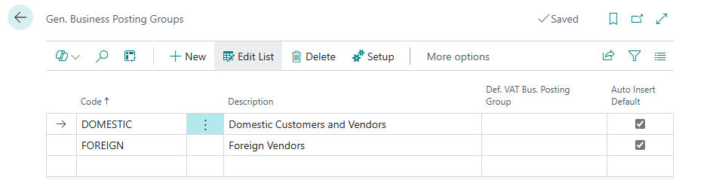

Gen Prod Posting Groups

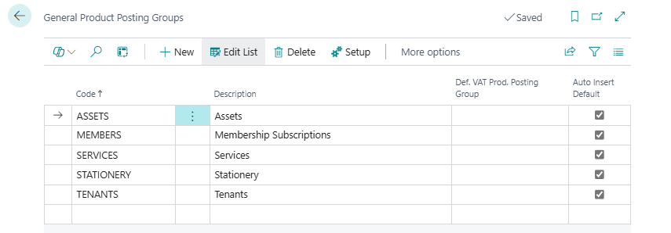

VAT Bus Posting Groups

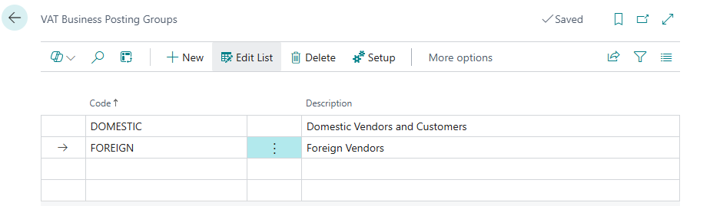

VAT Prod Posting Groups

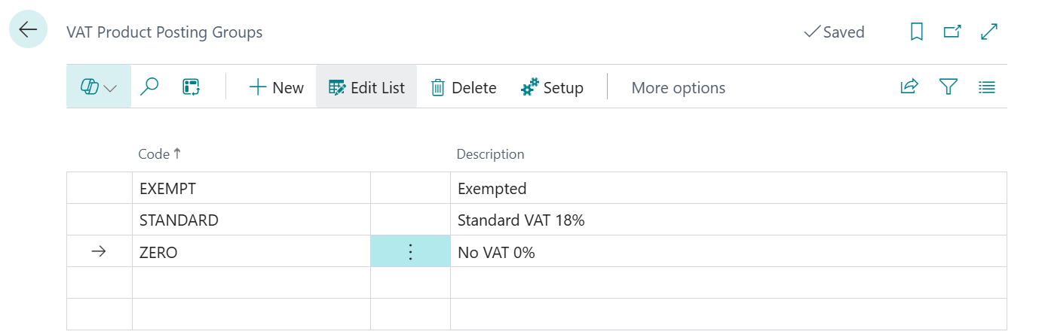

VAT Posting setup

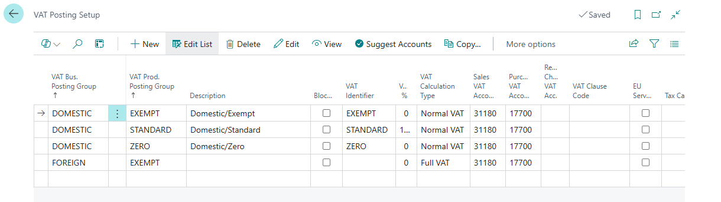

Gen Posting Setup

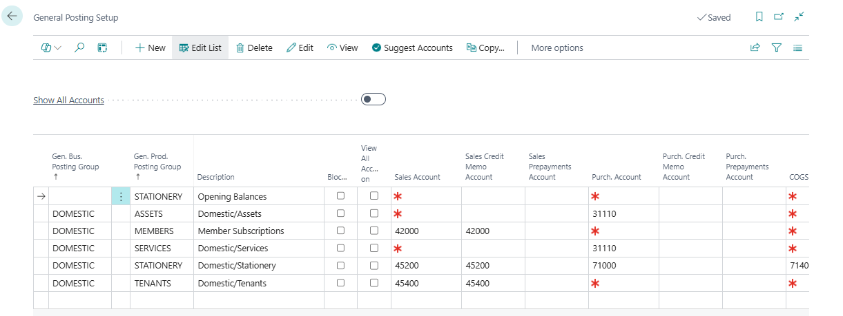

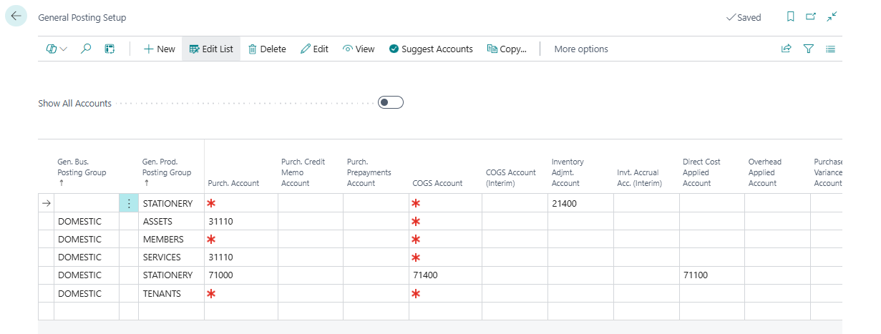

NB: In the General Posting Setup for Inventory Purch. Account is the Purchase Control account in the Income Statement

FA Posting Groups

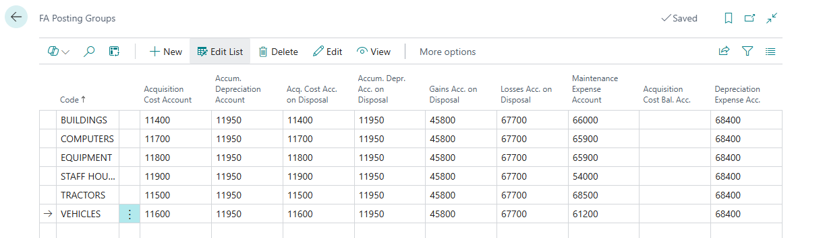

Customer Posting Groups

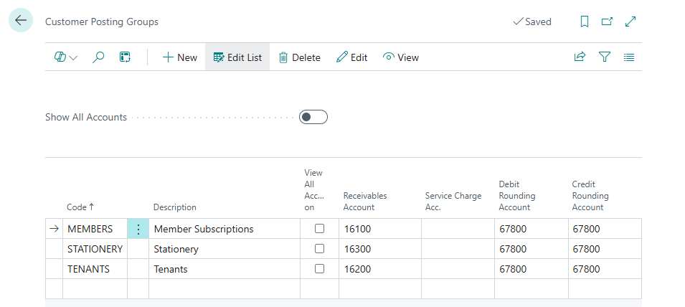

Inventory Posting Groups

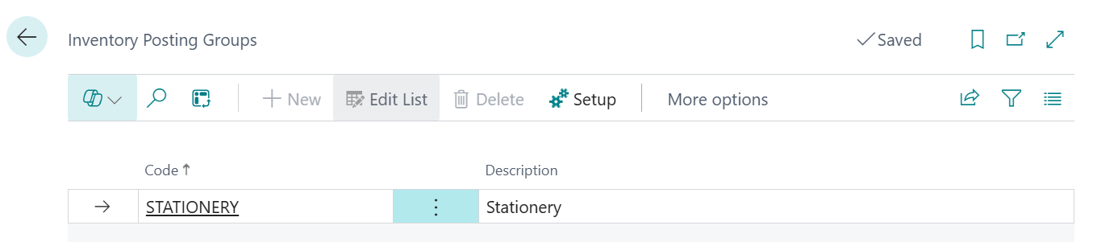

Inventory Posting Setup

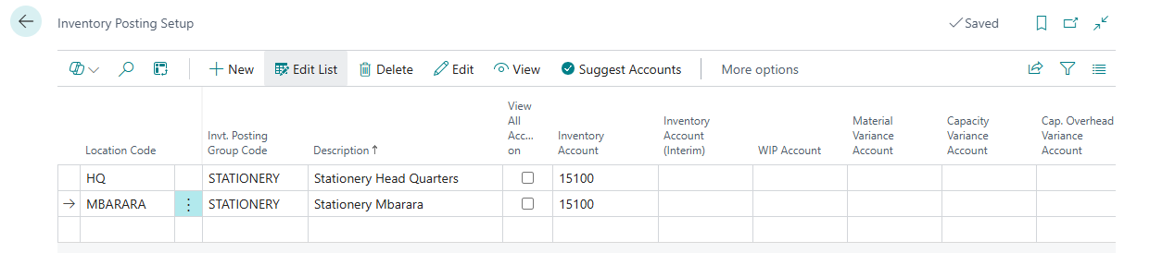

**HUMAN RESOURCE**

**Payroll Groups**

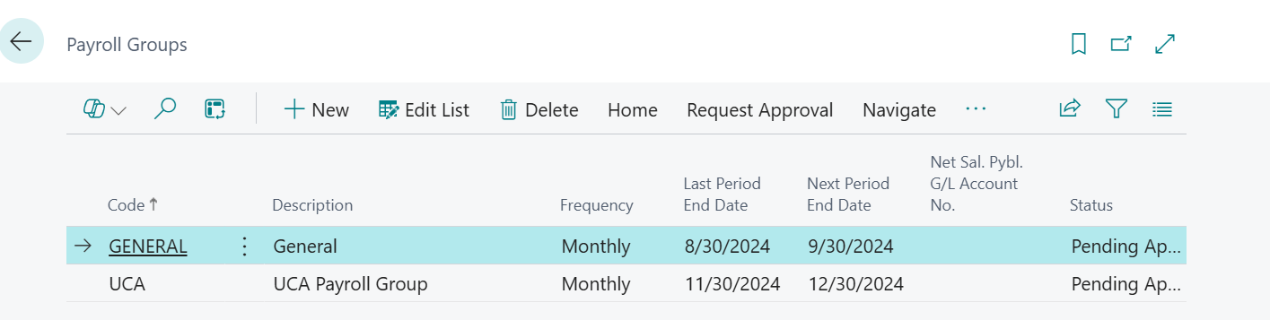

Payroll Items Table PAYE Tax

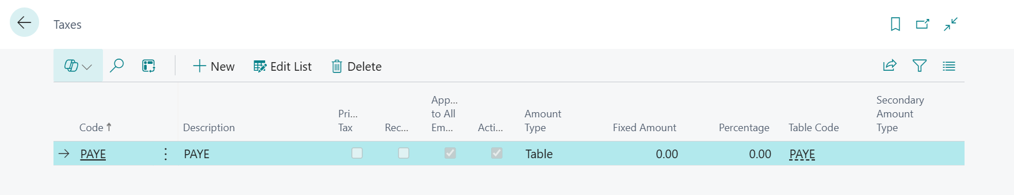

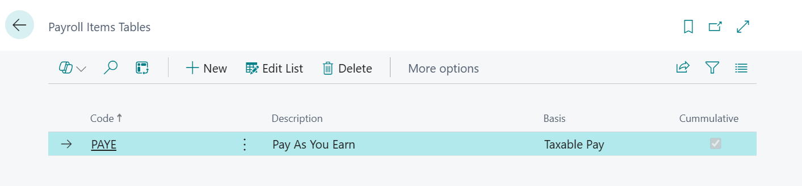

Payroll Deduction Table Lines

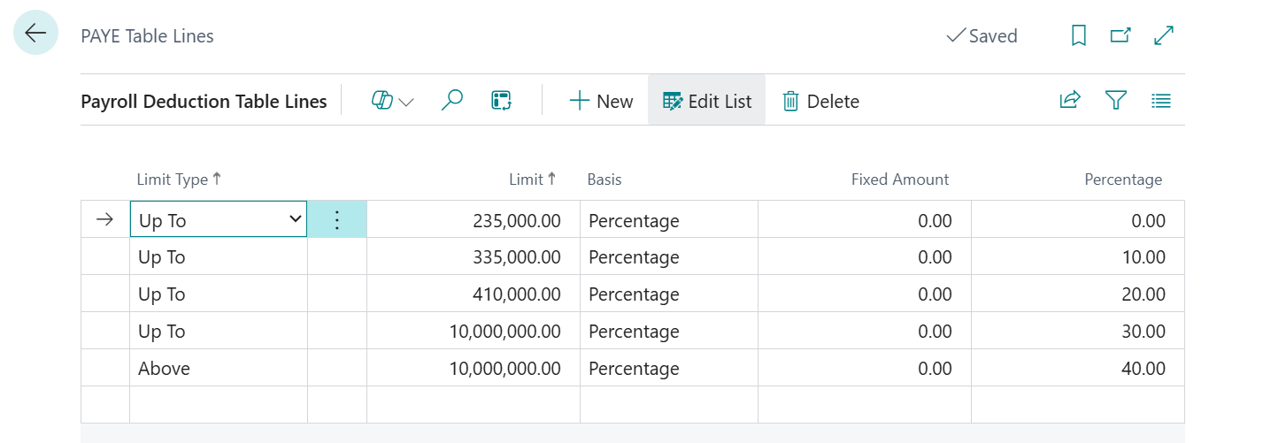

NSSF Deductions

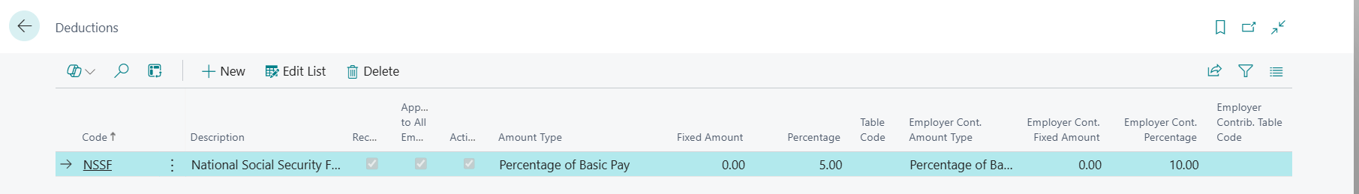

SACCO

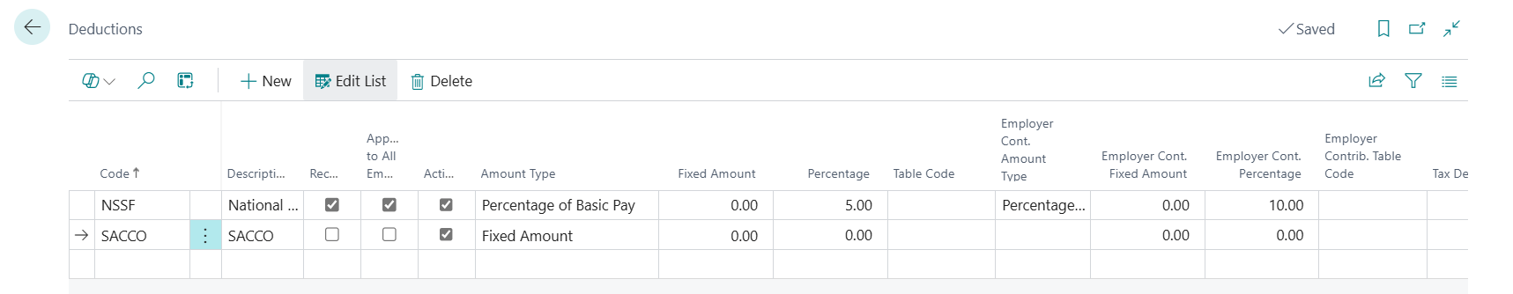

After this then go to Employee Card and attach the amount

Payroll Posting Setup  
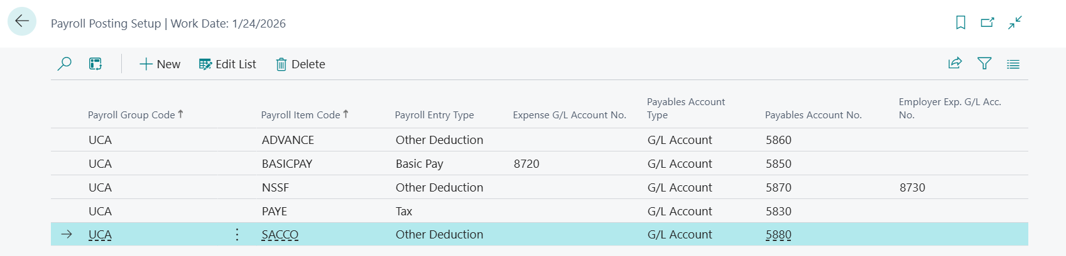

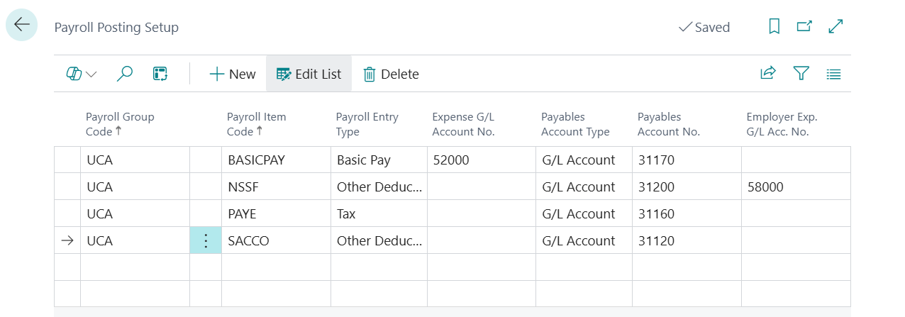

NB: Payables Account in Employee Posting Groups should be the same as the one on Payroll Posting Setup Basic Pay payable account.

Employee Posting Groups

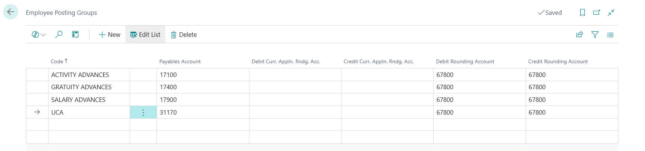

Tenants Setup (Pay VAT 18%)

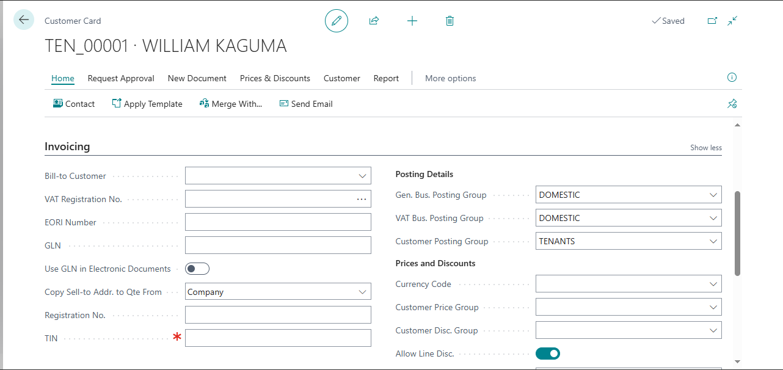

Income Account Setup for Rent

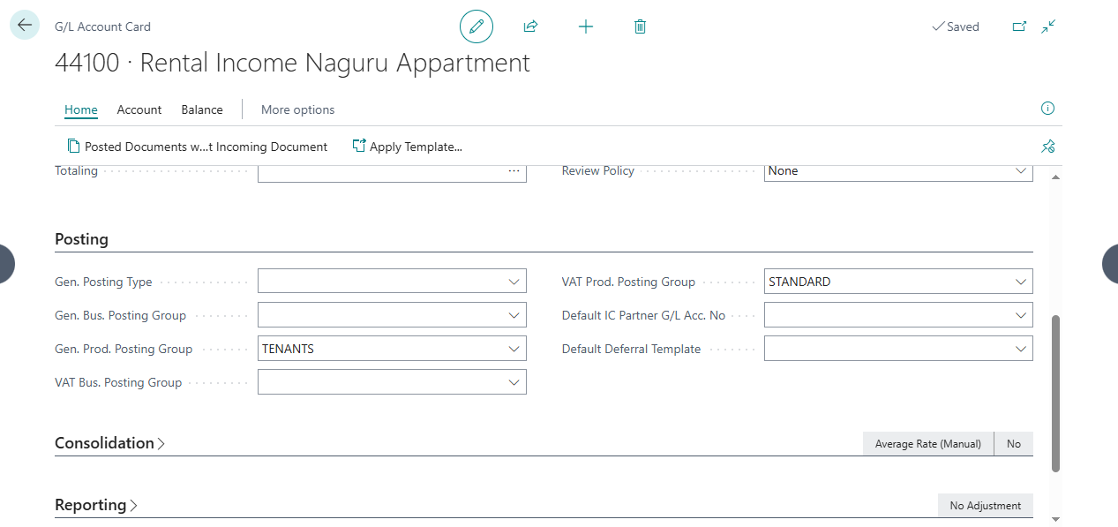

Members Setup

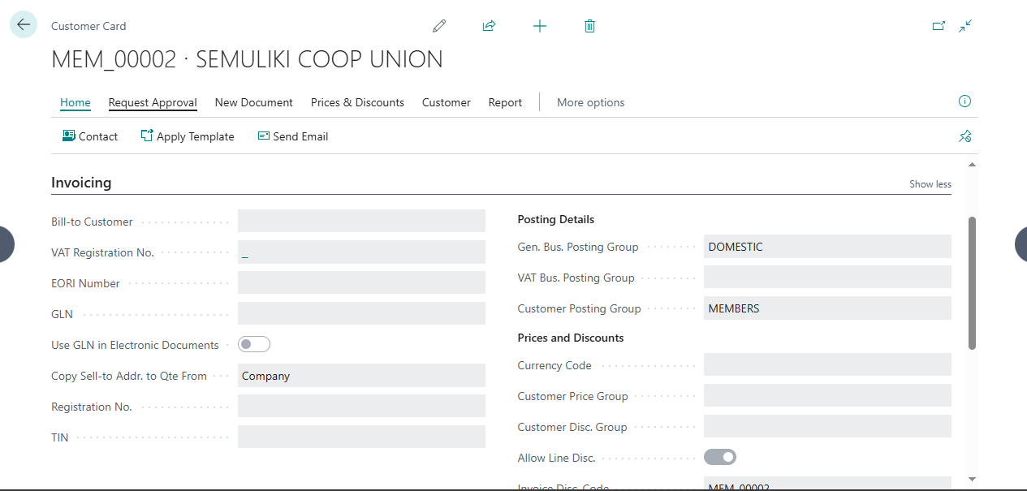

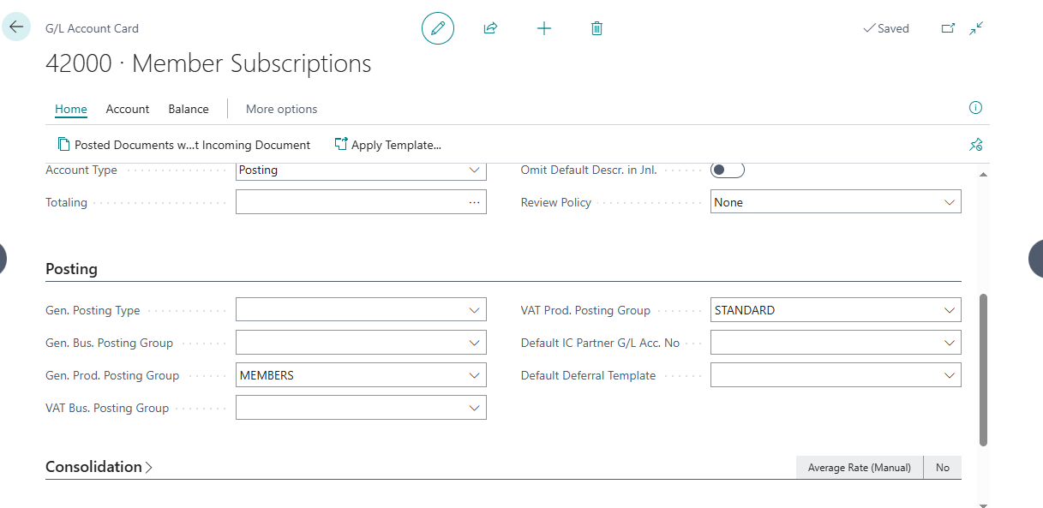

Stationery Setup

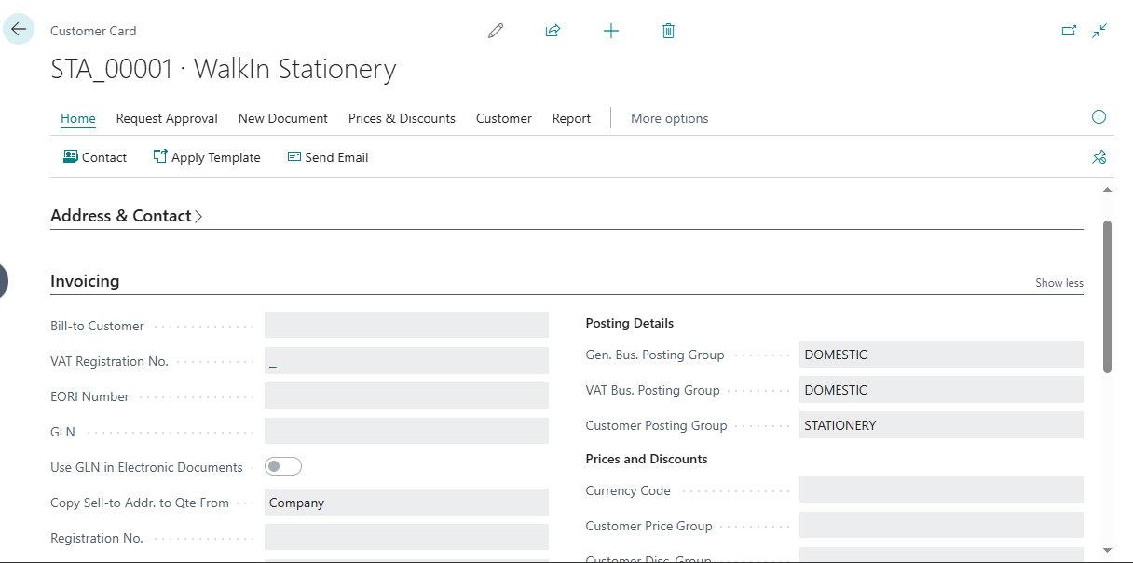

Vendor

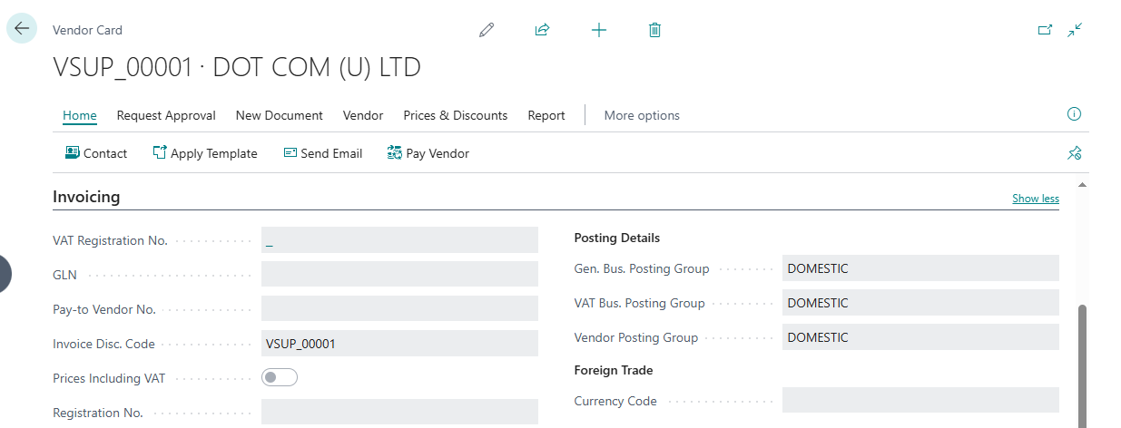

Purchase Account for Fixed Assets  
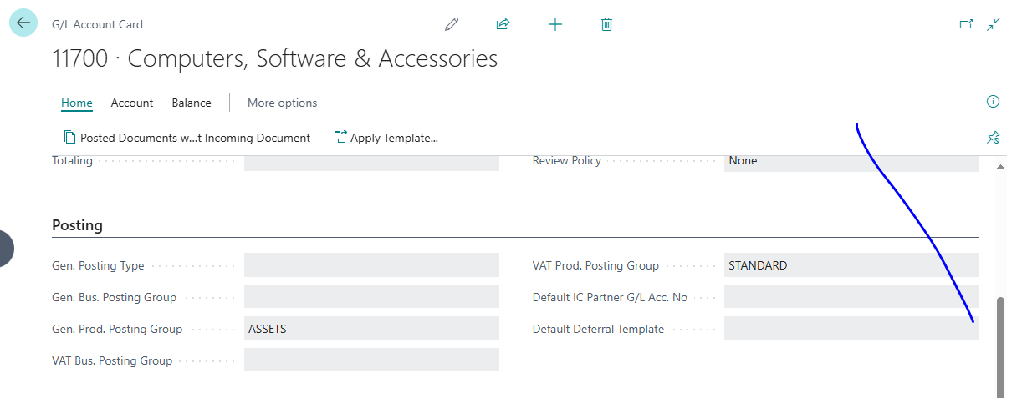

Purchase for Services

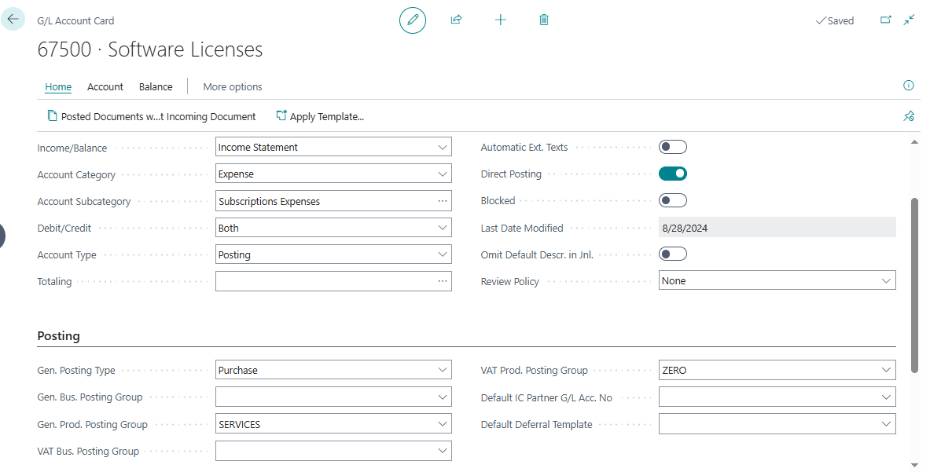

NB: Do the same to other accounts under Property, Plant and Equipment except Accumulated Depreciation account only

Tenant Setup

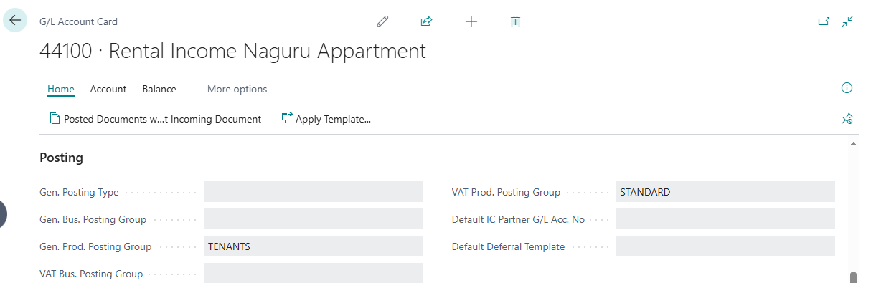

Fixed Assets

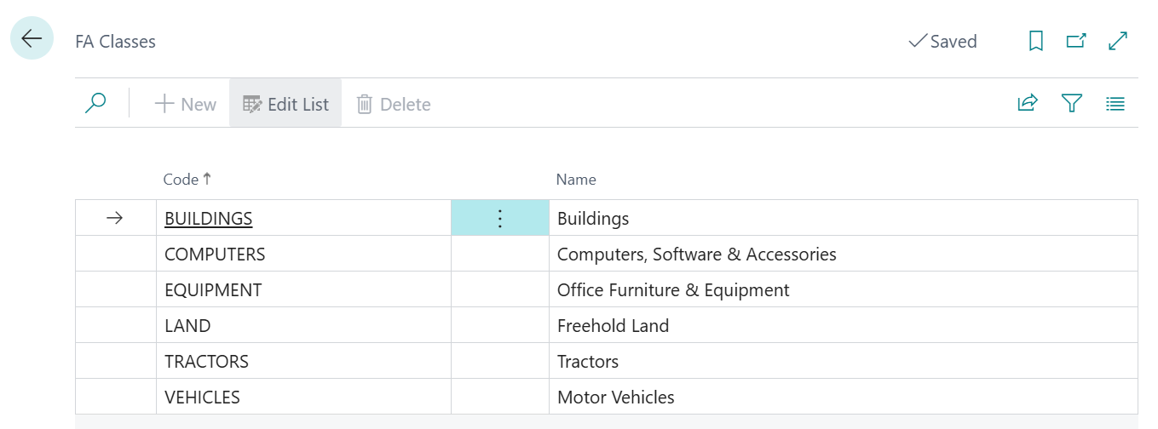

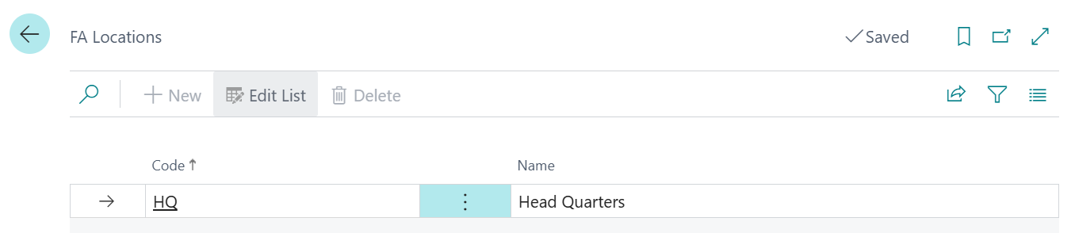

No Series

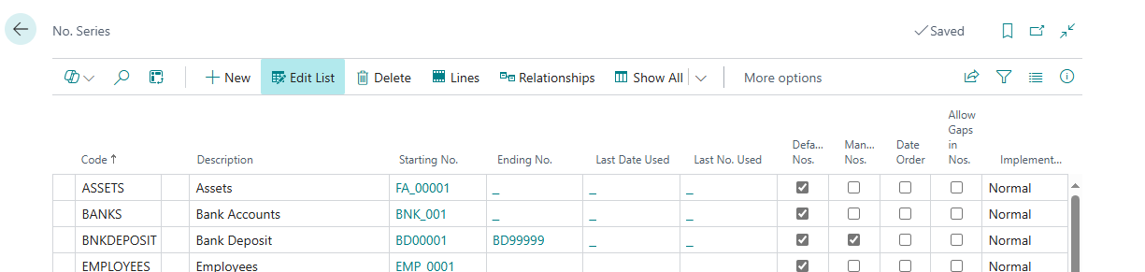

Bank Account Posting Groups  
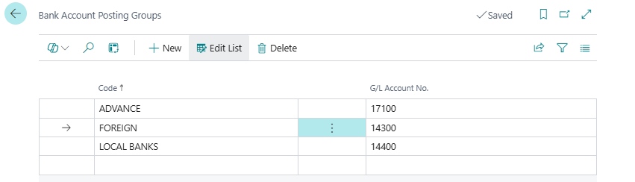

Currencies

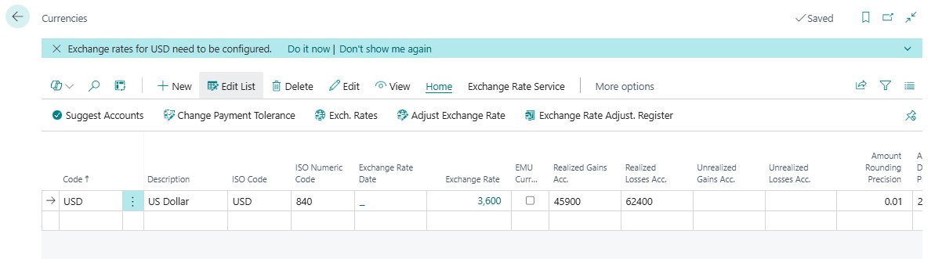

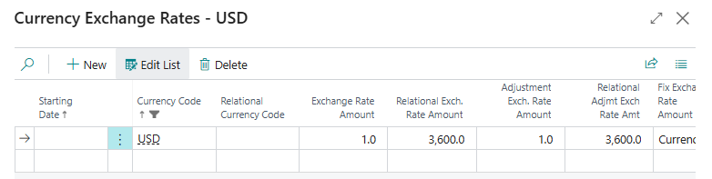

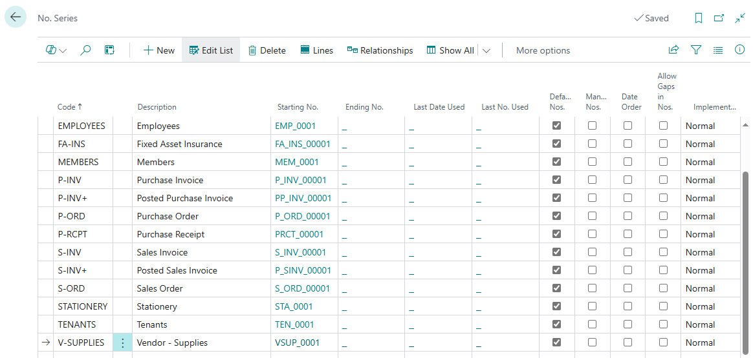

**Opening Stock/Stock in process in Business Central**

Create opening Balances account in Equity.

Create a General Posting Setup for it.

Use Item Journals to post

Turn on Automatic Cost Posting in Inventory Setup

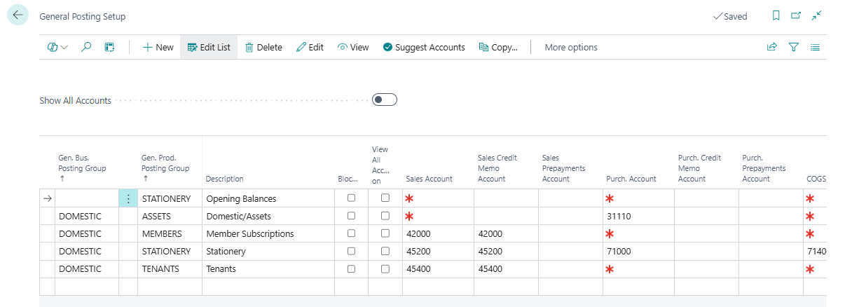

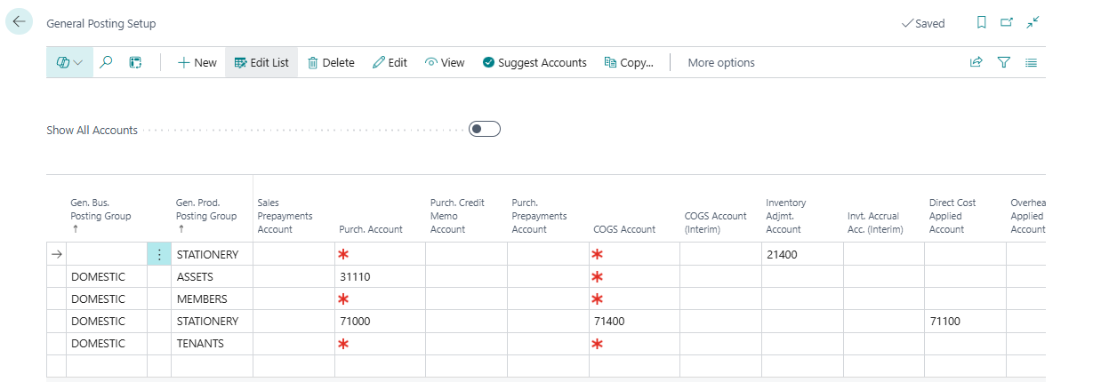

To setup a No. Series to be used for Item Journals go to No. Series create it then go to Item Journal Templates then click on Batches action and attach in No. Series. NB: **A No. Series is only assigned to the Journal Batch.**

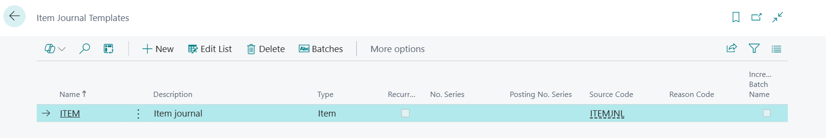

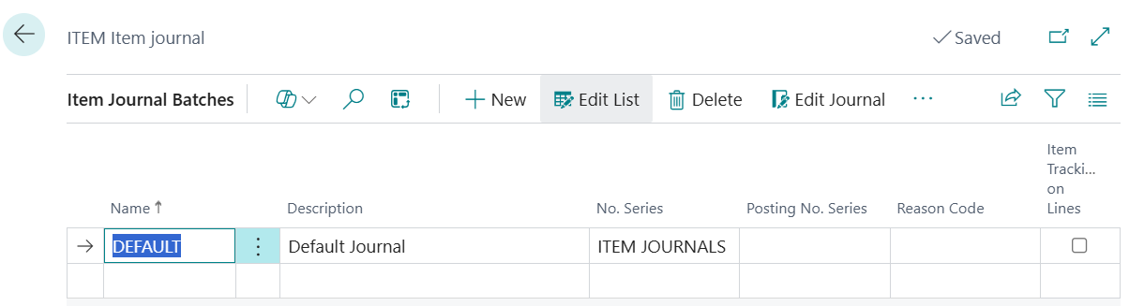

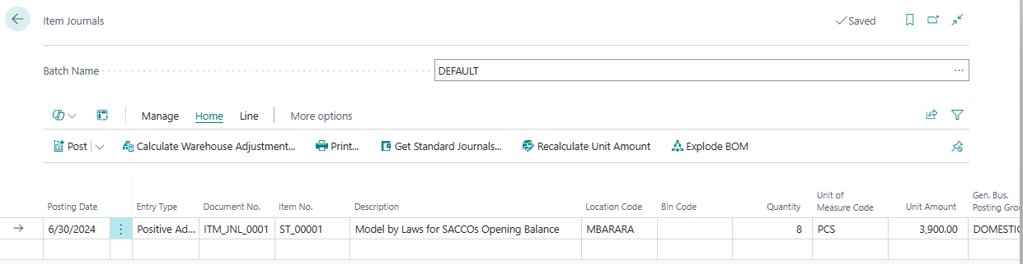

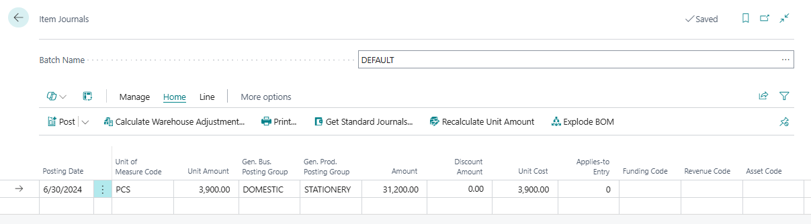

**Recording Advance for Employee**

So, the second line helps to account for the advance to offset employee. It will credit the advances account because of the settings in employee posting groups, then debit expense and lastly credit employee to balance the employee also off.

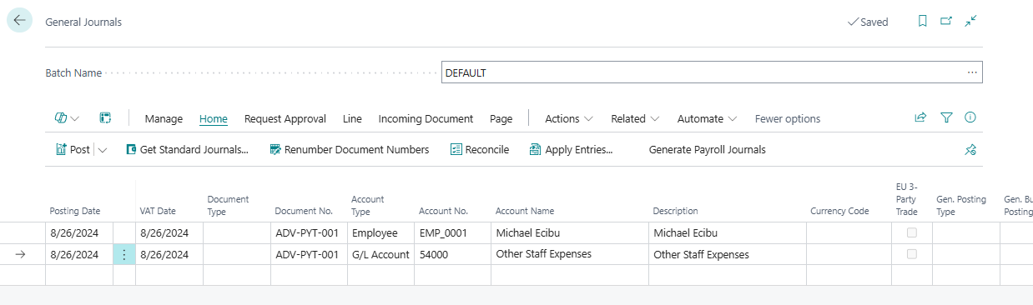

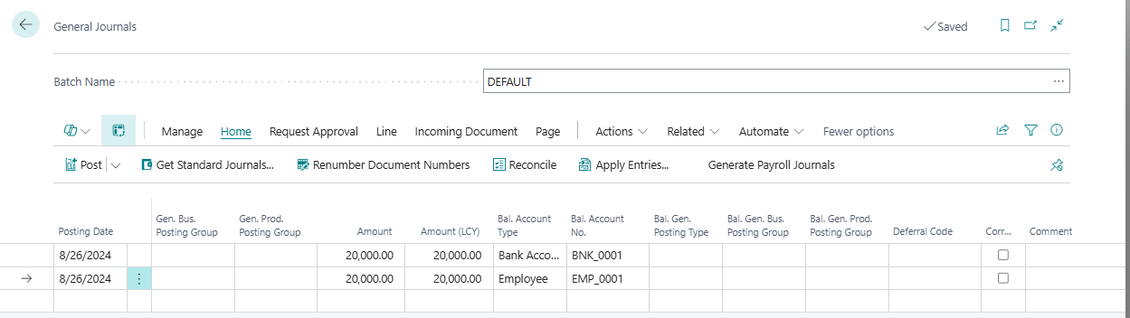

**Giving Gratuity and Activity Advances**

**Giving the Advance**

Go to General Journals and chose Employee and specify the Employee Posting Group then move to the next line and put the Bank Account to be credited.

**Accounting for the Advance**

Go to General Journals and choose the G/L Account (Expense Account) and put amount move to the next line and put the employee and specify the Employee Posting Group and amount in negative

**Record Fuel Expense**

First setup Fuel Expense account from Chart of Accounts

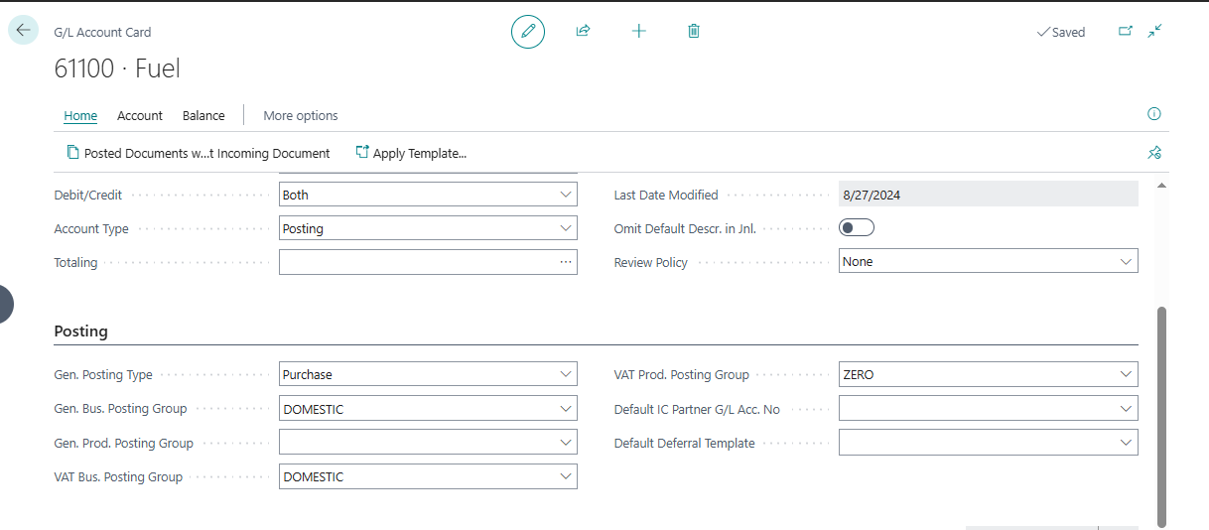

Now go and Post General Journals if no vendor but if the vendor is there Go to Purchase Orders and create one then in the lines select the Expense G/L Account.

The same applies to all expense that have vendors if there is no vendor use general journals

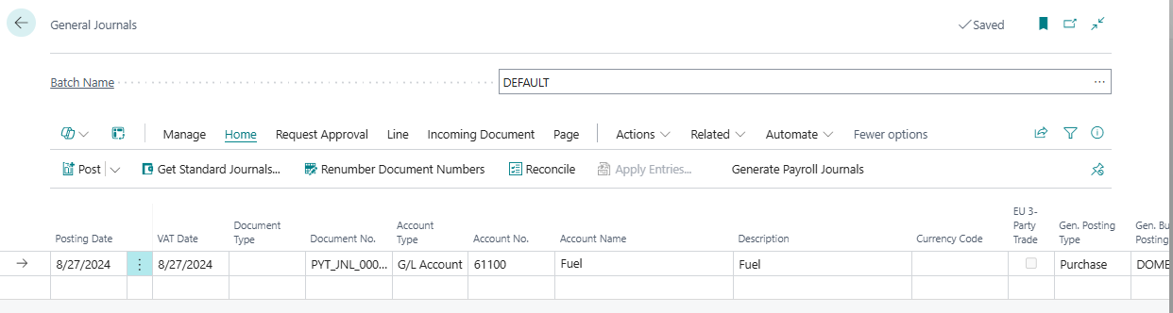

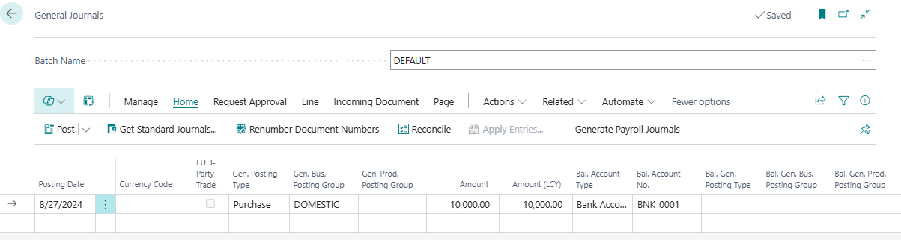

Repairs & Maintenance Expenses

If VAT is there create the lines then in the bal account type select your bank or

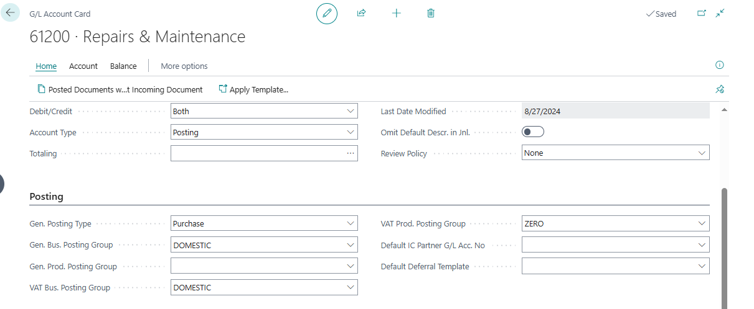  
Go to General Journals and choose that account

**Setting up No Series relationships**

Create your No Series and create the one for relation then on top click on Relationships on the action bar

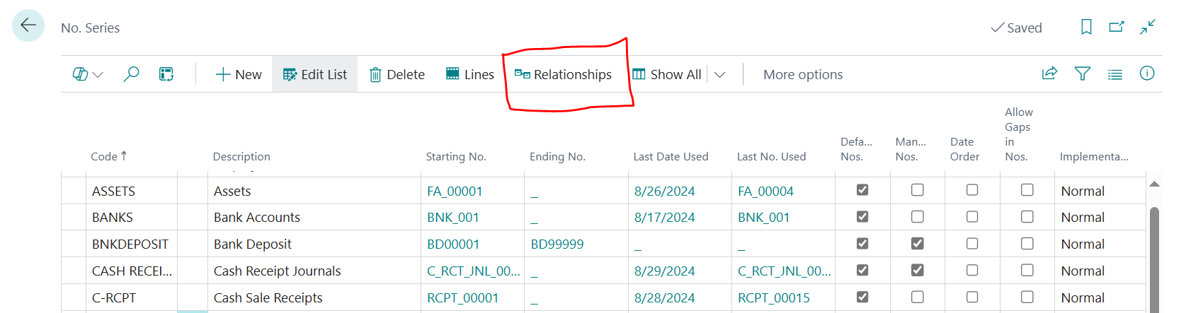  
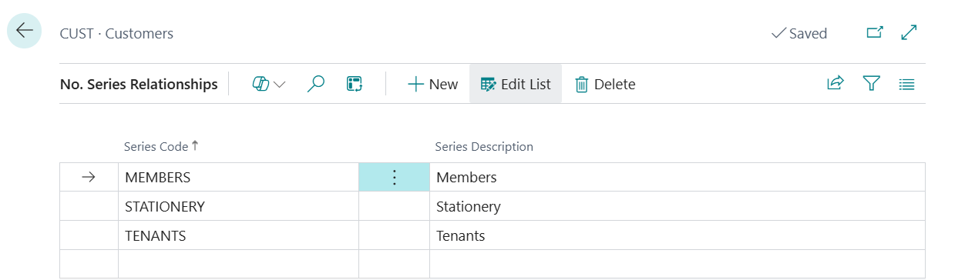

NB: Cash Payment Voucher

**Recording Utilities on Sales Orders for tenants**

Create Utilities as a service item then configure the Gen prod posting group

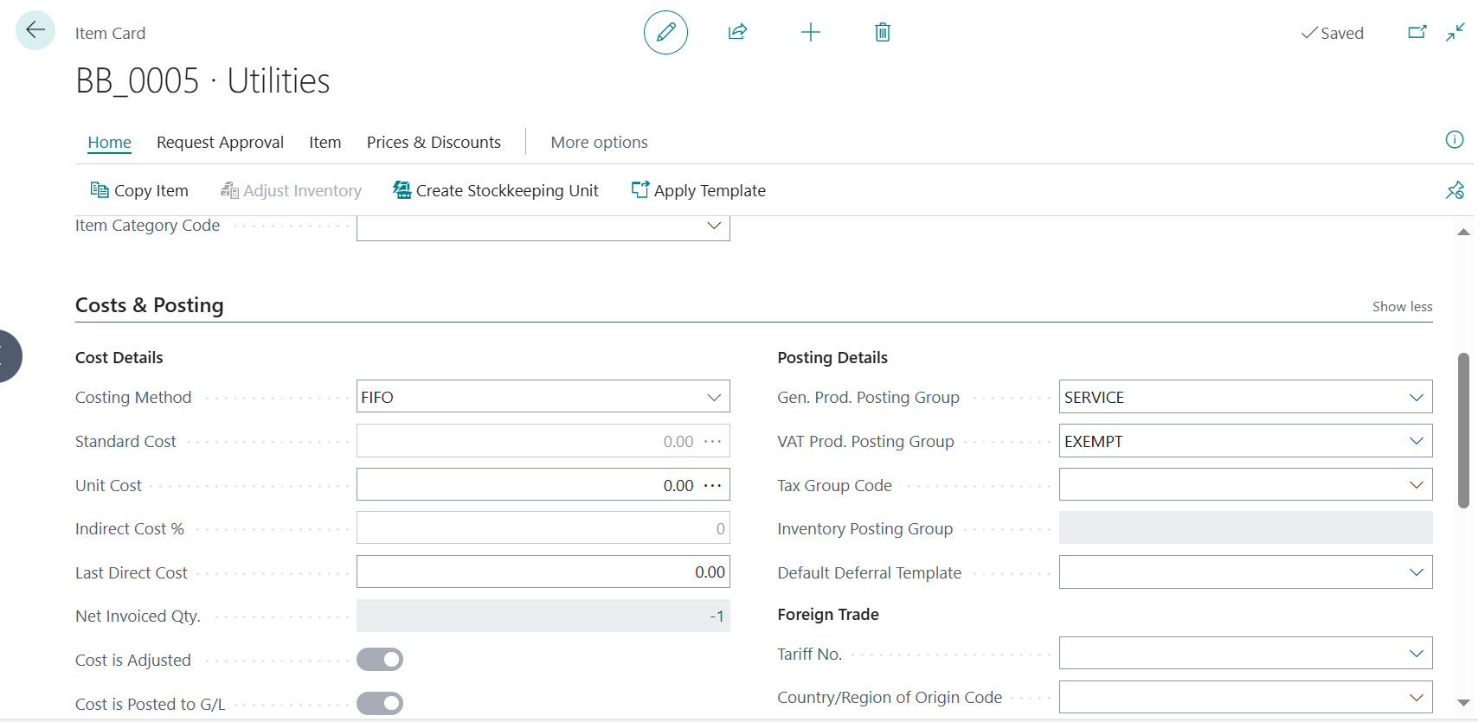

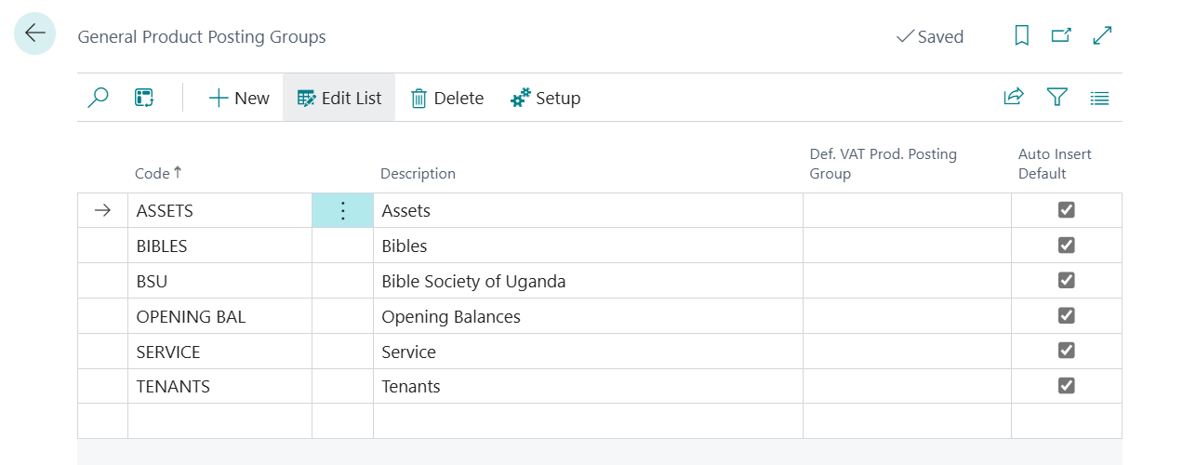

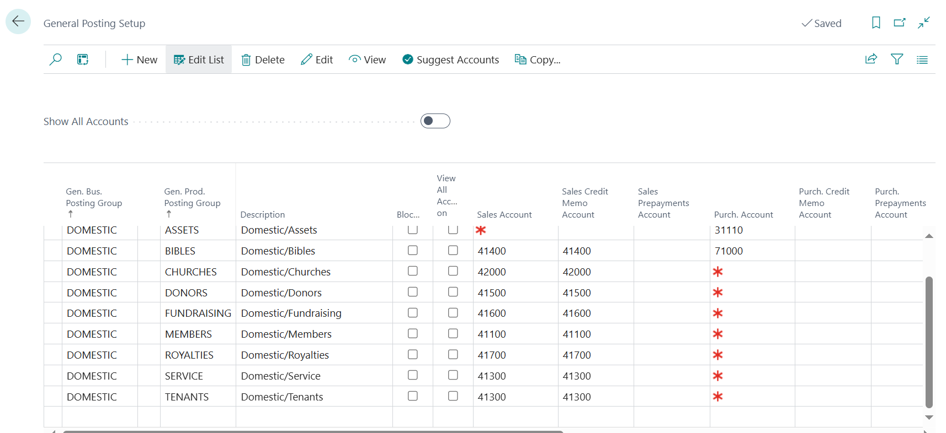

Sales Account is the revenue or income account so if you want Utilities to be recorded separate create revenue account from chart of accounts and assign it as sales account as revenue account.

The same to shares and entrance fees.

**Rent Calculations**

Get total monthly amount divide by number of months to get amount per month and for vat get 18% of monthly amount

**Record rubbish income or scrap income**

Go to General Journals the select the income G/L Account and put amount as negative and put Bank Account number

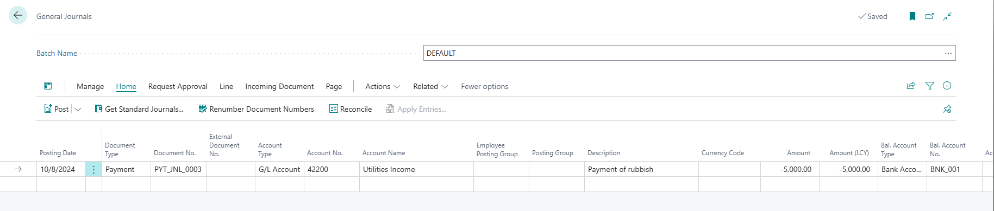

**If a vendor does work for us and they are both customer and vendor**

**Use payment journal and put them on the left as debit and right customer as credit**

**OPENING BALANCES**

Create a GL Account under Equity for Opening Balances

**Bank Accounts/GL Accounts**

Go to General Journals and Debit Bank Account and Credit Opening Balances account. So on the lines select bank account and balancing account as Opening Balances.

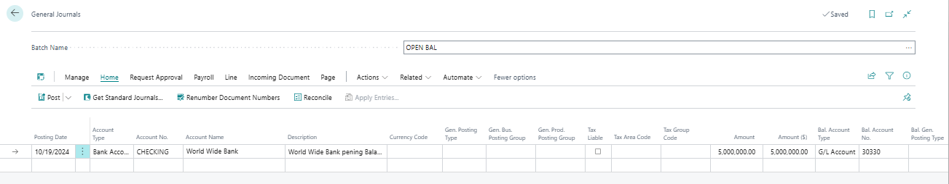

**Customers**

Go to General Journals Debit Customer and Credit Opening Balances. So select customer and Opening Balances as Balancing account.

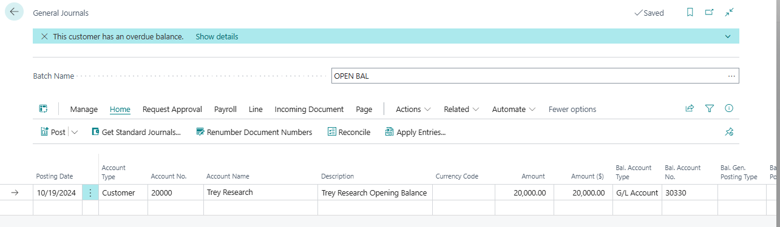

**Vendors**

Go to General Journals Debit Opening Balances and Credit Vendor or Loan (all liabilities)

